TECH SPEC
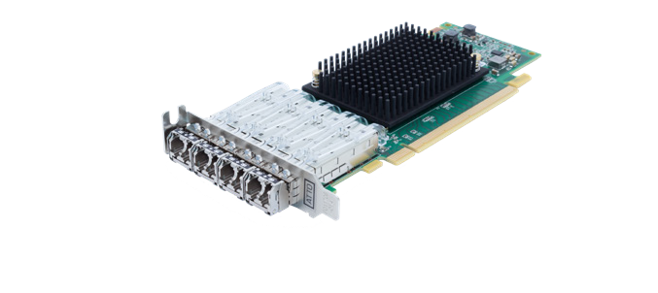ATTO Celerity™ 32Gb Gen 7 Fibre Channel HBAs
Celerity FC-324P
32Gb Gen 7 Fibre Channel Host Bus Adapters

Industry Proven Technology
ATTO has over 30 years of experience developing and delivering reliable first-

ATTO Celerity™ 32Gb Gen 7 Fibre Channel host bus adapters provide the highest performing SAN storage connectivity
for physical and virtual infrastructures.

Technical Features
- Single–, dual-, and quad-channel configurations (SFP included)
- 3200 MB/s per channel throughput
- Driver support for Windows®, Linux®, macOS®, illumos, VMware® and more
- ATTO Advanced Data Streaming (ADS™) Technology
- ATTO ConfigTool™ for customized performance settings
- Proven interoperability with leading storage hardware and software vendors
- Support for N_Port ID Virtualization and Virtual Fabric
- Target mode (Developer, SCST, LIO and more) support
- Three-year standard product warranty
- Low power consumption
- Trunking (Port Aggregation) with Brocade Switches
- Silicon Root of Trust for authenticating firmware
- Fast Path architecture for latency improvement

MultiPath Director™
- Multiple paths to storage for improved data integrity and reliability
- High-performance shared storagefor workgroups
- Load-balancing and failover in heterogeneous OS environments
- Available through authorized OEMs
to-market Fibre Channel storage connectivity solutions to customers. ATTO Celerity™ Fibre Channel connectivity solutions are consistently the highest- performing host bust adapters (HBAs) for server virtualization deployments, faster backups and scalable cloud initiatives. Offering performance to match new multi-core processors and faster PCIe 4.0 server host bus architectures, the integrated family of Celerity 32Gb Gen 7 Fibre Channel HBAs boast an extensive list of customer design wins and certifications with respected industry partners.

Flexible Connectivity
With single-, dual-, and quad-channel configurations, Celerity 32Gb Gen 7 Fibre Channel HBAs are an ideal solution for users looking to achieve the highest I/O and data throughput for advanced video and enterprise-class IT applications. Celerity 32Gb Gen 7 HBAs offer driver support for Windows®, Linux®, macOS®, illumos, VMware® and more, providing a single connectivity solution for customers with heterogeneous operating system environments.

Performance Engineered
Celerity HBAs are designed to provide fast, redundant and highly available connectivity to Fibre Channel storage and are engineered to manage latency for real-time applications. ATTO Advanced Data Streaming (ADS™) Technology provides controlled acceleration of data to deliver the most consistent performance and reliable data transfers. Specialized Fibre Channel drivers with support for multiple OS platforms and OEM-specific solutions, such as target mode and multipathing, make ATTO the premier choice for high-performance Fibre Channel storage area network (SAN) connectivity.

Advanced Managment Tools
Easy-to-use ATTO ConfigTool™ features an intuitive GUI that simplifies the installation, management and monitoring of the HBA. With advanced
troubleshooting and performance tuning capabilities, Celerity HBAs provide users with sophisticated diagnostics and the flexibility to control settings for specific applications.

About ATTO
For over 30 years, ATTO Technology, has been a global leader across the IT and media & entertainment markets, specializing in network and storage connectivity and infrastructure solutions for the most data-intensive computing environments.
ATTO works with partners to deliver end-to-end solutions to better store, manage and deliver data.
The Power Behind the Storage +1.716.691.1999 | atto.com

Applications
ATTO Celerity™ Fibre Channel HBAs deliver high-performance and reliable connectivity solutions for the most demanding storage environments, including physical and virtual data centers, tape streaming and backup, rich content delivery and server clustering. Celerity HBAs enable users to achieve the ultimate in I/O performance for real-time and transactional applications.

Advanced Data Streaming (ADS™)
Latency-management technology that controls the acceleration of data transfers to move large amounts of data faster and more efficiently.

Key Features
- Auto Negotiation to 32Gb, 16Gb and 8Gb devices
- Supports point-to-point and direct fabric/switch attach
- ANSI Fibre Channel: FC-FS, FCP
- Flash ROM for easy field upgrades
- Fibre Channel Class 3 Support
- Buffer Credits: 80
- Pluggable optical LC SFP+
- ATTO Branded SFPs must be used
- Initiator and target mode (OEM) support
- Supports FDMI and WMI
- Supports NPIV and Virtual Fabric
- Supports Thunderbolt™ technology

User Benefits
- Superior performance for enterprise applications
- Increased switch port availability
- Seamless integration into existing Fibre Channel SANs
- Extensive certification with SAN infrastructure components
- Support for virtualized server environments

Management Tools
- ATTO ConfigTool™ and ATTO vConfigTool™ management and configuration utility
- ATTO Command Line Tools

Bus Specifications
- PCI Express 4.0 host interface (Single and Dual only)
- Supports PCI Express Base Spec 4.0
- Supports FC-PI-7
- Supports SFF-8431
- Supports PCI Express CEM Spec 3.0
- PCI Hot Plug spec 1.1

External Connectivity
- Low profile brackets for FC-321P, FC-322P, FC-324P
- Pluggable 32Gb optical LC SFP+ modules included
- External LEDs for boot status and visual indication of the operating state

Operating System Support
- Windows®
- Windows Server®
- Linux®
- illumos
- VMware®
- FreeBSD
- macOS®

Agency Approvals
- UL, cUL, CSA: US and Canada
- TUV: Europe
- FCC class A: US
- ICES: Canada
- EMC Directives (CE Mark) Class A: Europe
- VCCI class A: Japan
- BSMI class A: Taiwan
- MSIP (Formerly KCC): Korea
- 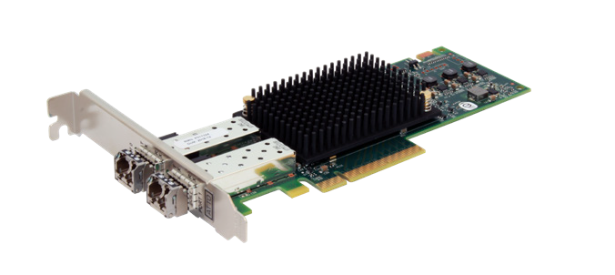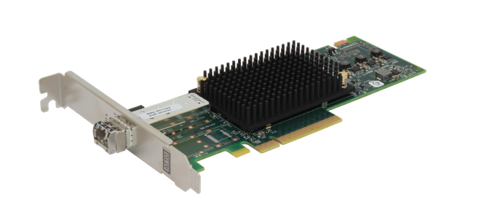RCM: Australia
Celerity FC-322P
Celerity FC-321P

Compliance
- RoHS (meet EU and China standards)
- TAA Compliant—Country of Origin USA

Dimensions
FC-321P, FC-322P, FC-324P
- Length 6.595”, Height 2.709”

Operating Temperature

Hardware Environment
- Temperature: 0-55° C
- Humidity: 10 -90% non-condensing

Storage Environment
- Temperature: -40°-70°C (-40°-157°F)
- Humidity: 5 -95% non-condensing

Operating Power (Typical)
- FC-321P: 9.8W
- FC-322P: 10.6W
- FC-324P: 24.9W

Warranty
- Three-year standard product warranty

The Power Behind the Storage +1.716.691.1999 | atto.com

ATTO Celerity | FC-321P | FC-322P | FC-324P
Ports | Single | Dual | Quad
Bus Characteristics | x8 PCIe 4.0 | x8 PCIe 4.0 | x16 PCIe 3.0
Form Factor | Low Profile | Low Profile | Low Profile
Max Transfer Rate | 3200 MB/s | 6400 MB/s | 12.8GB/s
SKU | CTFC-321P-000 | CTFC-322P-000 | CTFC-324P-000

